Automated Vehicles-adoption, evolutionary, environment

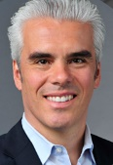
Speakers:
Jochen (Joe) Renz-is the co-founded New Mobility Consulting & New Mobility World. New Mobility help corporations, startups and investors take advantage of the opportunities associated with the digital transformation of transportation and mobility.

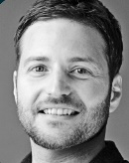
Noah Levens COO, HAAS Alert

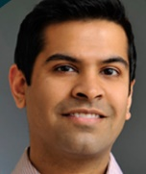
Brian Droessler-Head of Software and Connected Solutions, Interior Division, Continental AG Infotainment and Connectivity Business Unit-Panelist
Aashish Dalal- Co-Founder & CEO ParkWhiz-Moderator

FOOD PROVIDED!!
Data: November 30
Time: 6-8 pm
Location: IIT Chicago-Kent College of Law, DTC CK 590
565 West Adam Street, Chicago IL, 60661
RSVP:

